How to generate the transcriptome reference
- Download the genome .fa
  - Convert it to a format: 50bases /line → reformat it to 1line/ chromosome
# genome reformatter : 1line/ chr
more hg19.fa |perl -ane 'chomp; $x = $_; $x = "\n".$_."\n" if /^\>/; print $x;' >jk
more jk |perl -ane '$i++; print if $i > 1;' > jk2
echo 1|perl -ane 'print "\n";' > jk2
cat jk jk2 > hg19_reformat.fa
rm jk
rm jk2
- Download from raw transcript positions from: http://genome.ucsc.edu/cgi-bin/hgTables
  - Settings: [see screenshot]
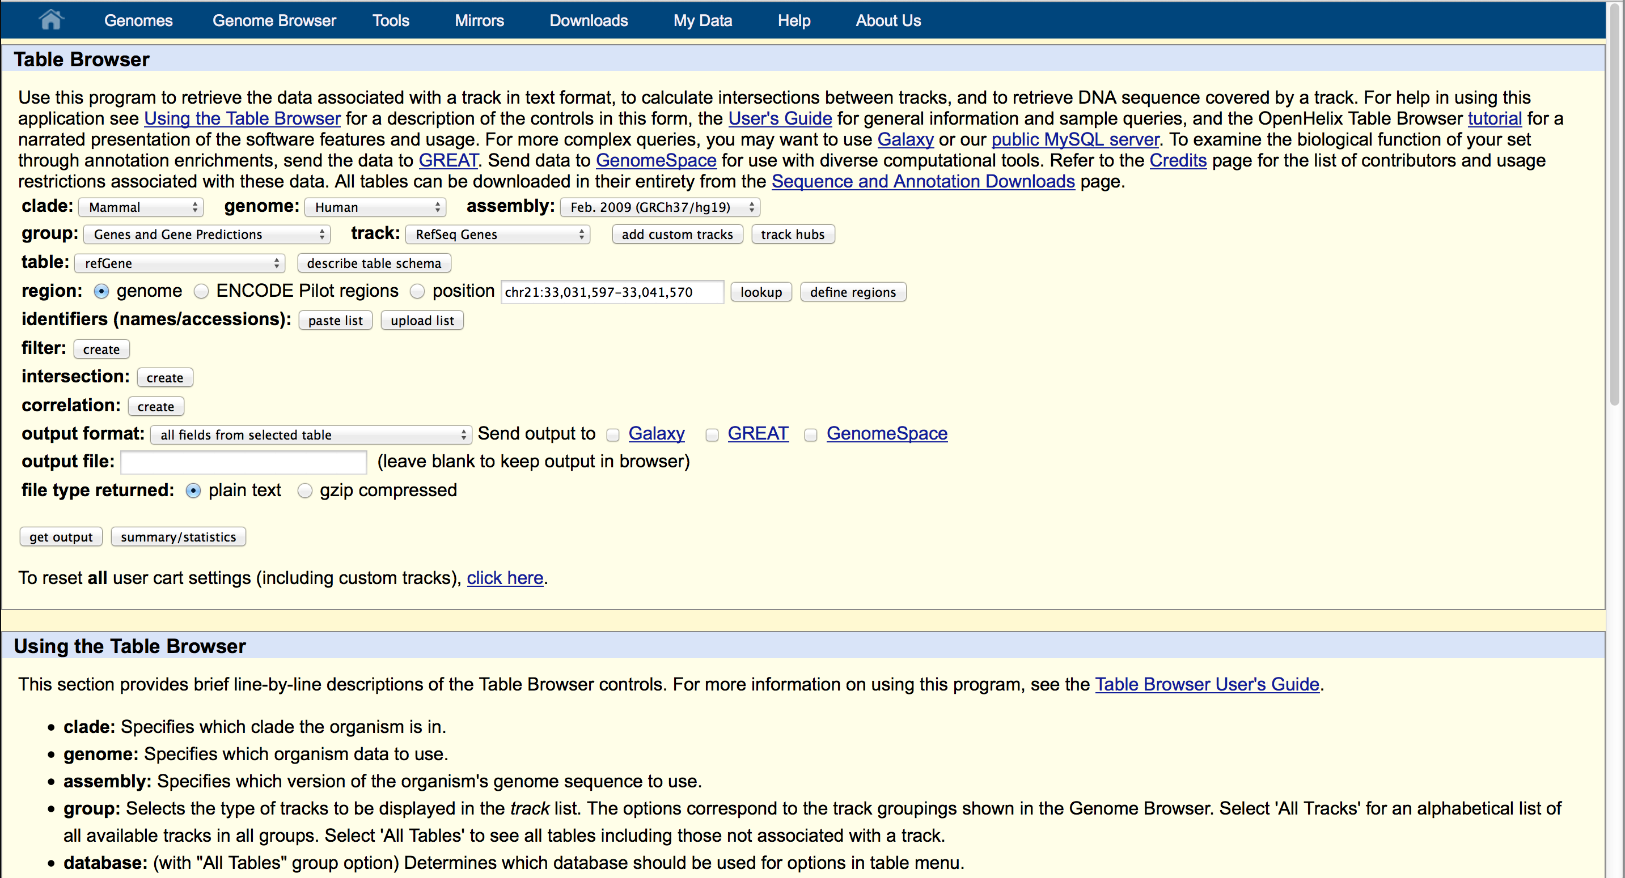
- Transform ucsc it into gtf format with ucsc2gtf.pl
  - gtf 1 line per exon, multiple isoforms for the same gene follow each other: each marked by 'transcript' in col3
- Merge of all exons in all isofroms merge_isoforms_gtf.pl
  - Output: similar to a .gtf, but only one ‘block’ of exons for each gene
- Now make use of the reformatted genome: extract sequences with gtf2fa.pl
- Add the SPikeIn-is from ERCC92.fa
cat hg19_RefSeq_genes.fa ERCC92.fa > hg19_RefSeq_genes_ERCC92.fa
- Make an index with bwa

